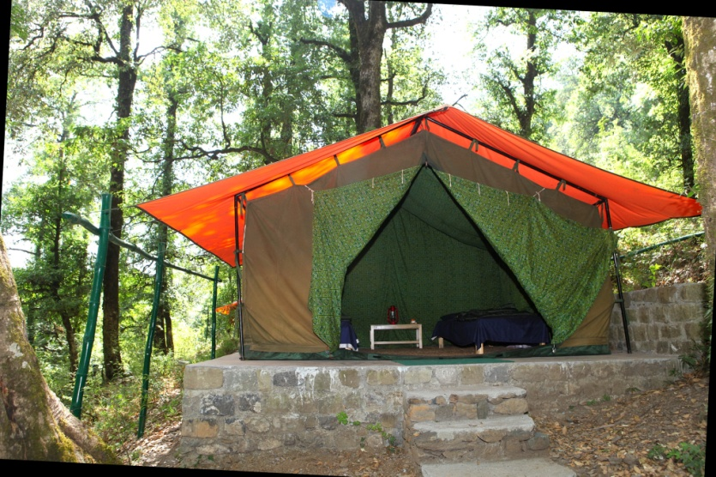

TREKKING IN HIMALAYA
PINDARI GLACIER > ALTITUDE : 3820 m.
Duration : 7 Night 8Days
Ex. Kathgodam
Season : April to June & September
To November.
PINDPARI & KAFNI GLACIERS >
ALTITUDE : 3820 m. & 3840m.
Duration : 9 Night 10Days
Ex. Kathgodam
Season : April to June & Sepember
To November.

SUNDERDHUNGA GLACIERS &
MAIKTOLI BASE CAMP >
ALTITUDE : 3880 m.
Duration : 11Night 12Days
Ex. Kathgodam
Season : April to June & September
To November.

MILAM GLACIER > ALTITUDE : 3872 m.
Duration : 11Night 12Days
Ex. Kathgodam
Season : April to June & September
To November.
ROOP KUND > ALTITUDE : 5029 m.
Duration : 8Night 9Days
Ex. Kathgodam
Season : April to June & September
To November.
MILAM GLACIER > ALTITUDE : 3872 m.
Duration : 11Night 12Days
Ex. Kathgodam
Season : April to June & September
VALLEY OF FLOWERS > ALTITUDE : 3962 m.
Duration : 6Night 7Days
Ex. Kathgodam
Season : July to August

KADARNATH - VASUKITAL> ALTITUDE : 3962m.
Duration : 7Night 8Days
Ex. Rishikesh
Season : April to September
TUNGNATH -DEVARIYATAL> ALTITUDE : 2286m.& 2438m.
Duration : 6Night 7Days
Ex. Rishikesh
Season : April to September
KAURI – PASS TREK> ALTITUDE : 4268 m.
Duration : 9Night 10Days
Ex. Rishikesh
Season : April to September
DODITAL TREK> ALTITUDE : 3307m.
Duration : 8Night 9Days
Ex. Dehradun
Season : April to September
HAR KI DOON TREK> ALTITUDE : 3566m.
Duration : 11Night 12Days
Ex. Dehradun
Season : April to September.

LOW ALTITUDE TREKS

NAINITAL TO KILBURY > > ALTITUDE :2194m.
Duration : 1Night 2Days
Ex. Nainital
Season : Round the year.
NAINITAL TO KUNJKHARAK > ALTITUDE :2650m.
Duration : 3Night 4Days
Ex. Nainital
Season : Round the year

NAINITAL TO CORBETT NATIONAL PARK > ALTITUDE :2194m. & 650m.
Duration : 1Night 2Days
Ex. Nainital
Season : Round the year.
NAINITAL TO RANIKHET > ALTITUDE :2250m. .
Duration : 5Night 6Days
Ex. Nainital
Season : Round the year.

